Community Strategic Planning: Reduction of Drug Experimentation Among Adult Youths
Student name
Institution
Course
Date

Abstract
A lot of young adults now have tended to experiment with drugs before they reach adulthood. This usually happens due to curiosity during teenage age and hence starts trying on new substances into their bodies. This is a health problem among young adults, and quick action needs to executed to prevent drug experimentation. Thus, this essay will be focusing on the community's strategic plan to reduce drug experimentation among young adults. The information about the research was obtained from various articles on health care management.

Introduction
Once the first try is done, using the drug becomes experimental, thus occurring regularly. Most of the youth start this by using drugs on precise occasions like parties or an event so that they can have more fun. When teenagers reach this stage, they generally don't think before they start using them. Thus, the youth begin consuming the drugs, knowing what the potential outcome will be, and they use them without pre-planning. Community strategic planning is an administrative action that is usually set to identify the significances, making the operations to prevent drug experimentation, thus ensuring that the adult youths are also working toward the common goal of reducing drug experimentation. Effective community strategic planning does not only show where the plan of lowering drug experimentation and actions that need to be taken but shows if the reduction in drug experimentation among adult youths will be successful.
Youths using drugs so that they can get high has been rising in recent times, and it is becoming a challenge among the adult youth in the United States of America and all other places in the world. Teenagers in the United States spend about $800 billion yearly on drugs, and this is a big challenge to the country. For instance, the statistics that were released by the Centre for Disease Control indicate that more than 48,000 people died in the year 2017 due to drug usage. Drug-related deaths have increased among adult youths since the year 2019 started, and it is because of using substances like cocaine, heroin, and opioids. Between the years 2014 and 2017, the number of deaths increased up to 400% as a result of using drugs (Delva, Spencer, and Lin,2018, p.78 ). As a result of drug consumption in the United States, healthcare cost has increased double and productive is declining among adult youths. Thus, this essay is directed to using the community strategies plans to reduce drug experimentation among the adult youth hence reducing the costs applicable to healthcare on drug consuming problems.
Strategic Plan To Reduce Drug Usage Among Youths.
As most of the dugs have been used excessively, it has become a challenge in reducing drug usage. The figure below shows a community intervention framework that can be used to reduce drug use in the community. It consists of the prevention measures that should be taken to reduce drug use.
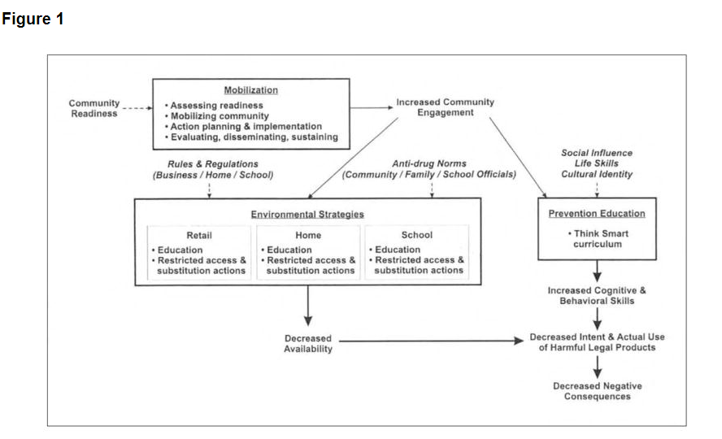
Five variables are regarded to be important in the reduction of drugs among youths. The variables have been indicated with italics in Figure 1 above. The variables are rules and regulations, community readiness, social influence, anti-drug norms, and cultural identity. When it comes to community readiness, it usually defines how the community should respond to how youths use illegal products effectively and the actions the city will take to reduce drug usage.
Under the variable rules and regulations, it describes the limitations on the presence of drugs and substance in homes, schools, and even retail stores. On social influence, variable deals with the social force that is from the teenagers, parents, and society, in general, that will reduce or increase the consumption of these drugs (Anderson and Loomis, 2016,p.87). Anti-drug norms usually describe the level at which families, officers of the school or local retailers are concerned about drug use in the community and the actions they are taking to prevent usage. On cultural identity, it defines all the beliefs, attitude, and activities that are associated with specific people in the society.
If the variables indicated in figure 1 above are taken into consideration more effectively, they will form three based community prevention intervention methods that will help in reducing drug experimenting among adult youth. The plans are; mobilizing the community, putting strategies in the environment we live, and education that is given in schools. These methods are instrumental as they have been scientifically proved.
Mobilizing the Community
This strategy was formed to increase community enthusiasm and involve them in controlling activities and the actions to be taken for reducing drug experimenting among adult youth. The effort to reduce alcohol consumption in the society through community mobilization gives support to prevention actions and increasing more members in advocating for the reduction in drug experimenting. When mobilization of the community is active, it is easy to implement reducing activities such as environmental strategies and education in schools. For community mobilization to be effective, there must be steps that should be taken in mobilizing them and are as follows; the community should be accessed so that to ensure that it is ready for executing the roles given. The second step is to build a base. The third step is expanding the bottom, then develop the plan to be completed, executing the stated policy, asking for the feedback, and the final step is to maintain the effort in carrying out the actions.

On Home Environmental Strategy
Parents are the ones given the role of prevention of drug experimentation among adult youths. This strategy intends to encourage parents so that they can restrict their children from accessing harmful legal substances (Swahn, Hammig, Ikeda,2017,p.201). The actions that should be taken by parents to ensure that they prevent drug use are; having conversations with their children on the dangers and challenges that are associated with using of drugs, parents should locate risky products that might be found within home environment, ensuring that available harmful legal products that are found within are controlled. The final action is the advocation of preventing drug substances among the parents in society.
School Environment.
In the school environment, there exist a lot of components that might be inhaled, such as paints, glue, highly concentrated alcohol products, and many other more. The school environment supports both home and retail strategies so that they can restrict the usage of drug substances. The actions that can be taken to ensure that school strategy is effectively working are; school staff must be aware of the products that are brought into school, giving procedures for safe and appropriate using of harmful legal substances in school, Administration should put limits on legal and dangerous products that can be found in the school environment, and the last action is for the school to substitute the harmful legal products with safe ones.

Environmental strategies
This strategy is meant to increase both the social and physical environment at large to reduce drug experimental among the youths. It has been scientifically proven that if the environmental strategies are effectively executed, it will reduce drug experimenting among the youth. The ecological areas that are concerned with the reduction of drug abuse are schools, homes, and retail shops. The strategy is meant to reduce the consumption of drugs among adult youths. The determination of whether the teenagers will use the substances is on the availability of these substances in the environment. The same factors in the environment are the ones that will reduce the abuse of substances in the environment. For instance, an increase in tax on cigarettes will help in reducing tobacco use in the environment. The environmental strategies target in correcting the community structures instead of individual behavior.
Environmental strategies consist of three environments, and they are retail, school, and family. In retail, it comprises actions that the community and retailers take to reduce drug use among adult youth. The actions that can be taken are; identification of high-risk products, making of retail policies that are directed to sale of harmful substances, post warning signs, dealing of products that of low risk, and the final action to be taken is enhancing restrictions on selling to the adult youth.
Prevention of education.
The education that is being offered in schools among the youths is a historical strategy that can reduce the usage of drugs among adult youth. The life skills lessons that are offered reduce eagerness to drug experimentation and reduction in social influence from the environment that may lead to drug usage, (Edelman et al, 2013). For instance, life skills education for American Indian youths reduced their use in harmful legal substances such as marijuana and alcohol. Therefore, life skill education has been effectively put into action among the American Indian populations because it is effective in drug use among adult youths

Conclusion
To prevent adult youths from consuming harmful legal products to get high, community intervention must be involved. Community prevention intervention is made in such a way that it increases community involvement so that they can execute the strategies that will reduce drug experimentation among adult youths. The community prevention intervention should be tested, and the outcome of the trial should constitute the use of drug substances to get high and the challenges that arise as a result of using drugs. The community prevention intervention enhances us to understand the complex method of reducing drug experimentation among adult youths.

References

Edelman, C., Kudzma, E. & Mandle, C. (2013) Health Promotion Throughout the Life Span. (8th edition)
Swahn MH, Hammig BJ, Ikeda RM. Prevalence of youth access to alcohol or a gun in the home. Injury Prevention. 2017;8(3):227–230.
Anderson CE, Loomis, GA. Recognition and prevention of inhalant abuse. American Family Physician. 2016;68(5):869–874
Delva J, Spencer MS, Lin JK. Racial/ethnic and educational differences in the estimated odds of recent nitrite use among adult household residents in the United States: An illustration of matching and conditional logistic regression. Substance Use & Misuse. 2018; 35:1075–1096

APPENDIX A: THE COST OF SUBSTANCE ABUSE IN USD (BILLIONS)
